TEMPLATE BLURB FOR NEWSLETTER / E-NEWS:

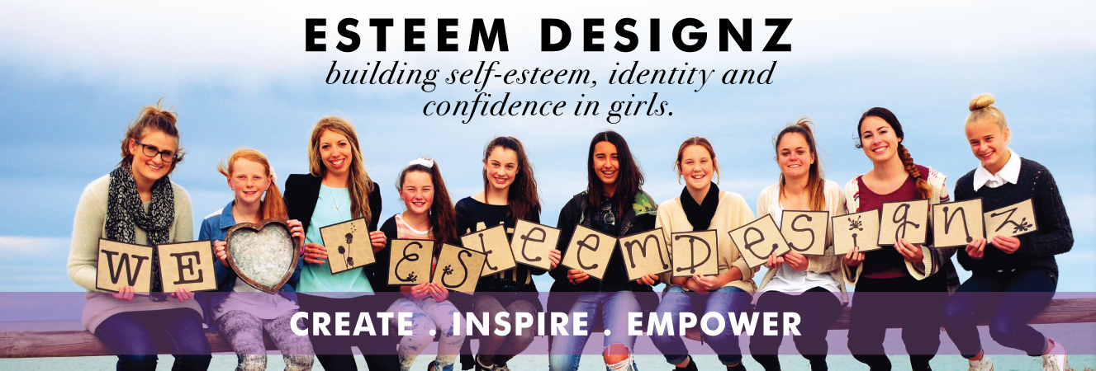

EMPOWERING TOGETHER

As part of our student wellbeing framework and personal development for our [year group] girls, we are really excited to be running Esteem Designz Program this term.

Esteem Designz Program helps girls to be confident in who they are, develop social and emotional skills, and learn some coping skills for life in a fun and creative program.

It is a program encouraging girls to explore self-esteem and identity through creativity. It is based on fun, interactive and meaningful design projects and activities. These are created to engage, equip and empower girls to discover their unique characteristics, finding value and respect in who they are, reinforce resilience, celebrate others instead of comparing, provide tangible tools for life and achieve goals that boost self-confidence and worth.

You may also notice some ChooseREAL posters around the school, helping us spread the message that every student, staff and school community member is MORE THAN ENOUGH, just as they are.

When we are bombarded with the message of NOT ENOUGH, through media and our culture’s unrealistic expectations, this is an important message we hope to impart and encourage our community with.

If you would like to continue this message throughout your homes, visit www.chooseREALcampaign.com for more resources.

BASIC BLURB ABOUT THE ESTEEM DESIGNZ PROGRAM:

Esteem Designz – is a mental health resource building self-esteem, identity and confidence in girls - all through CREATIVITY. Girls are equipped with key skills and tools to endure and thrive through life’s challenges.

Esteem Designz aims to be a solution to the ever-increasing issues and confronting pressures girls are facing, providing fun, interactive and meaningful Design Projects and activities to resource schools/organisations and individuals to engage, equip and empower girls.

The Design Projects are expressive and practical tools / coping strategies that help girls navigate these challenging years and continue to use throughout life.

The target age is grades 5-9, but has been used effectively with younger girls and young adults.

Anyone can empower girls with Esteem Designz. The Facilitator Manual is easy to use and flexible to meet your group needs. No training required!

The girls receive beautifully packaged, ready-to-go, empowering kits. All the work is done for you.

Esteem Designz Program has been implemented in over 400 schools, welfare/community groups across Australia, impacting over 9,000 girls.

Website |Quick Clip | Info Pack

A F E W S T O R I E S O F I M P A C T:

” Esteem Designz changed my life and our whole grade! ” - Year 6 student
” 100% of my girls felt more confident in themselves after doing Esteem Designz Program. It was such a valuable and beneficial experience for them all. ” - Teacher, facilitating Esteem Designz
” Through Esteem Designz I discovered more about myself and learnt to trust and believe in who I am. Through the awesome projects I now know that I can cope with anything and learnt really helpful ways to deal with life… ” - Year 8 student

” We hoped for our girls to BREAK FREE and that is exactly what Esteem Designz Program enabled them to do, empowering them with practical strategies and confidence to overcome their struggles… ” ” - Social Worker

” Thank you for what you are doing. This is such a vital message and I desperately needed to hear it. You are giving me hope and the tools to create change. ” - Young Adult

